BLOB DETECTION AND EXTRACTION FROM BINARY IMAGES

BY
DEEPAK PK
(deepakpk009@yahoo.in)

Here I am going to explain the labeling method for blob detection and extraction from an binary image.
There are many blob detection algorithms which are more efficient and faster than the one which I have used.
Here the input is a binary image which contains only two colors. Here we have the two colors as black and white. Black for the blob and white for the background. Here we have the input source image.
We first check whether that image is byte binary or not. If not we cannot process it.
Then we change the color values of the blob and the background with new 2 values: 0 for background and 1 for the blob.
Now we start the labeling process where every pixel is scanned using a 3x3 kernel.
For every pixel we check whether it is white (background color) or not. If white then don’t process.
We also check whether all its adjacent kernel pixels are also of the same value. If yes then don’t process.
Now we check whether any of the adjacent pixels of the current pixel has any value. If so then find the minimum out of those values. Else increment the label index and use it instead of the minimum value for labeling all the black (blob) or labeled pixels in the kernel.
During labeling, if a pixel which is already labeled is to be re-labeled then replace all occurrence of that label from the image with the current label which is to be set.
Repeat this process until none of the pixels are to processed (labeled and re-labeling process).
Now based on the label values extract those pixels only and create the blob images from the source image.

Input test image
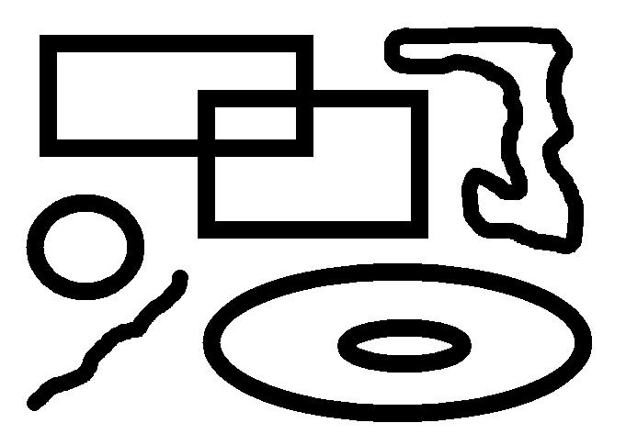
Detected blobs
blob 1
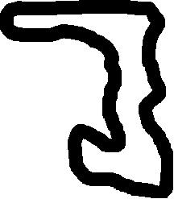

Blob 2
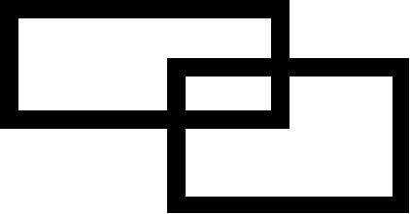
Blob 3

Blob 4

Blob 5

Blob 6


